**DAY-08**

**September 11**

**LOOPS:**

Loops in python are used to execute a block of code repeatedly until a certain condition is met.

​

Types of loops in python:

1.For loop

2.While loop

3.Nested loop

​

majorly it is only two types of loops for and while.

​

Nested loops can be further divided into 4 sub types:

1. * for loop inside for loop

2. * for loop inside while loop

3. * while loop inside for loop

4. * while loop inside while loop

1. For loop:

            In for loop we have two types

            1. for loop with sequence (string, list, tuple, dict, set)

            2. for loop with range

* For loop allows you to apply the same operation to every item within loop.
* Using For Loop avoid the need of manually managing the index.
* For loop can iterate over any iterable object, such as dictionary, list or any custom iterators.

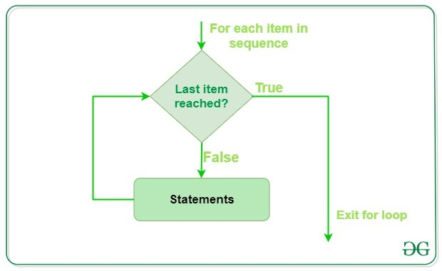

1. for loop with sequence

To print the name in character wise

name **=** "Indu"

print(name)

Indu

Using loop:

**for** i **in** name: *# i is iterative variable*

print(i)

N

a

r

s

i

Numbers are not considered as sequences. All the sequence data has a position.

​

example:

priyanka - sequence

12345 - not a sequence

to print position with character

enumerate is a function used to print position and character of the given variable.

output is a tuple consisting the position followed by character stored in the position.

​

**for** i **in** enumerate(name):

print(i)

(0, 'N')

(1, 'a')

(2, 'r')

(3, 's')

(4,’I’)

fruit **=** ['apple','mango','grape','pineapple']

print(fruit)

['apple', 'mango', 'grape', 'pineapple']

**for** i **in** fruit:

print(i)

apple

mango

grape

pineapple

In any other programming language we have three stages for range:

​

initialization

condition

increment/decrement

​

In python:

​

range(start value, stop value, step size)

​

step size +ve incrementation

step size -ve decrementation

*# 2.for loop with range*

​

**for** i **in** range(1,11,1):

print(i)

1

2

3

4

5

6

7

8

9

10

range(1,11,1)

(i**=**1;i**<**11;i**+**1)

i **=** 1,2,3,4,5,6,7,8,9,10

​

range(1,10,1)

(i**=**1;i**<**10;i**+**1)

i **=** 1,2,3,4,5,6,7,8,9

to repeat a statement for 20 times

**for** i **in** range(1,21,1):

print("Narsi")

Narsi

Narsi

Narsi

Narsi

Narsi

Narsi

Narsi

Narsi

Narsi

Narsi

Narsi

Narsi

Narsi

Narsi

Narsi

Narsi

Narsi

Narsi

Narsi

Narsi

**for** i **in** range(20):

print(i)

0

1

2

3

4

5

6

7

8

9

10

11

12

13

14

15

16

17

18

19

In range

default start value is 0

default step size is 1

If we are mentioning only one value in range then it will be considered as stop value.

we can skip both start and step values, but when u want to mention any one of them the other thing should be used compulsorily.

to print position and character using range function

name **=** "Narsi"

**for** i **in** range(0,4,1):*#in case of not knowing the length we can pass len(name) in that place*

print(i,name[i])

0 N

1 a

2 r

3 s

4 i

with length function

name **=** "Narsi Reddy"

**for** i **in** range(0,len(name),1):

print(i,name[i])

0 N

1 a

2 r

3 s

4 i

5

6 R

7 e

8 d

9 d

10 y

Write a program to print even numbers from 1 to 20

**for** i **in** range(2,21,2):

print(i)

2

4

6

8

10

12

14

16

18

20

Write a program to print 1 to 10 in the format

1 = odd number

2 = even number

​

​

10 = even number

**for** i **in** range(1,11,1):

**if**(i**%**2 **==** 0):

print(i, "=", "Even number")

**else**:

print(i, "=", "Odd number")

1 = Odd number

2 = Even number

3 = Odd number

4 = Even number

5 = Odd number

6 = Even number

7 = Odd number

8 = Even number

9 = Odd number

10 = Even number